**Characterisation and assessment of a surgical assessment unit (SAU) during the COVID-19 pandemic**

Hyunjin Shin1,2, Azka Yousaf1, Alexandros Siokos1, James McIrvine1, Chekwas Obasi1, Alok Mehta1, Hossein Arang1, Annabel Shaw1, and Jonathan Van Dellen1

1Croydon University Hospital, Croydon Health Services NHS Trust, Croydon, UK

2Princess Royal University Hospital, King’s College Hospital NHS Foundation Trust, Farnborough Common, Kent, UK

Corresponding author: Hyunjin Shin, BA, MS, MBBS

36 Chinbrook Road

London, SE12 9TH

[h.shin@nhs.net](mailto:h.shin@nhs.net)

+44-7492-055503

Lead consultant: Jonathan Van Dellen, MD (Res), FRCS (Gen Surg)

Consultant General Surgeon

Croydon University Hospital NHS Trust

Final word count: 1,997

None of the authors have any conflicts or financial interests to disclose.

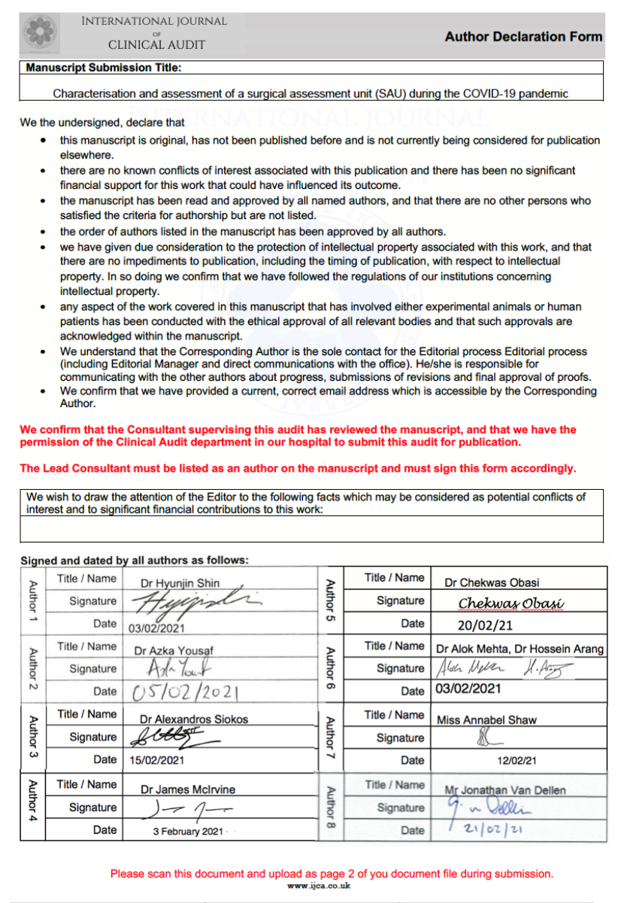

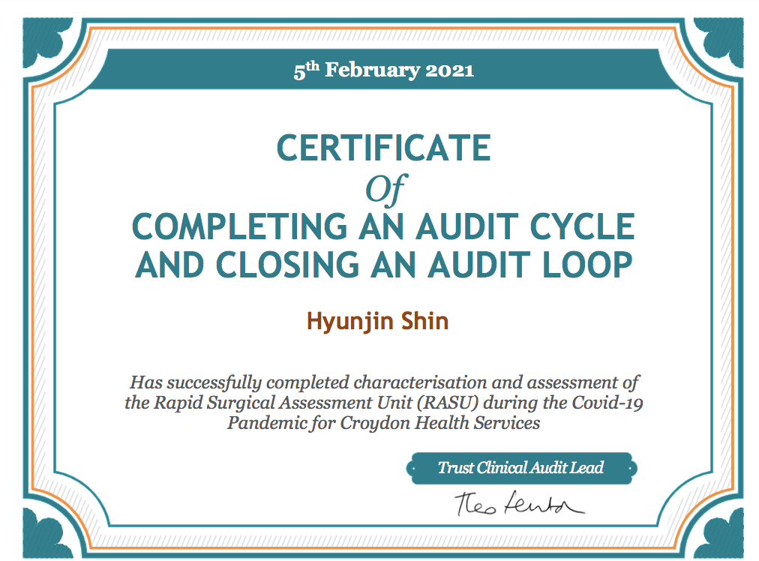

|  |  |  |
| --- | --- | --- |
| **CLINICAL AUDIT PROPOSAL FORM** | | |
| **PLEASE NOTE:**  Your proposal form will be reviewed by the Compliance and Audit team (CAT) and a decision made as to whether the team can support it; if supported you will be issued with an Audit Number. You must submit a completed Audit Report and Action Template to the CAT upon completion of your project, which will then be reviewed by the CAT. Your line manager/senior clinician must be named on this form and support your audit.  **CLICK IN THE BOXES AND START TYPING – THE BOXES WILL EXPAND TO FIT THE TEXT** | | |
| **SECTION 1** | **AUDIT SPECIALITY AND TIMEFRAME** | |
| Audit Title | Characterisation and assessment of the Rapid Surgical Assessment Unit (RASU) during the Covid-19 Pandemic | |
| Speciality(ies)of audit | General Surgery | |
| Name of Project Lead (s) | Annabel Shaw, Jonathan van Dellen | |
| Name of your line Manager | Stella Vig | |
| Date of this application | 12th June 2020 | |
| Start date of audit | 12th June 2020 | |
| Deadline of audit | 22nd June 2020 | |
| **SECTION 2** | **PROJECT AUTHORISATION** | |
| Name of the Specialty Clinical Lead | Stella Vig | |
| Contact Work Address | Croydon University Hospital | |
| Contact email Address (nhs.net email address) | Stella.vigs@nhs.net | |
| Extension | Via switch | |
| Bleep | Via switch | |
| Has the audit been discussed and agreed by the Clinical Lead (Y/N) | Yes | |
| **SECTION 3** | **DESCRIPTION OF AUDIT** | |
| **List the key improvements you want to achieve from the audit findings**  **1.** Assessment of the new Rapid Surgical Assessment Unit, created to streamline surgical assessment and management during the Covid-19 pandemic  **2.** Review of the patient pathway / flow, to identify improvements that can be made for the ongoing development of this pathway when coming out of the pandemic  **How have you tried to involve patients (service users) in this audit?**  Post-RASU attendance patient satisfaction questionnaire  **What are the guidelines or standards that you are auditing against?** *(Please enter the hyperlink to the guideline/standard or attach below a copy of the guideline/standard)*  See attached protocols / guidelines  **Please indicate whether the audit is linked to any of the following** *(Please double click on the check box and choose ‘checked’)*  X Trust Objectives  Care Quality Commission  National Audit programme/National guidelines/Royal Colleges  National Confidential Enquiry – e.g. NCEPOD  NICE - National Institute for Health and Care Excellence  X Local policy or guidelines  X Local Care Pathway  Trends identified via information from incidents, complaints and Litigation data  Re-audit  NPSA  Other (please specify)  **Is this audit based on an area of Trust:**  X High Risk  High Cost X High Volume X High Profile  **What are the likely benefits to the Trust as a result of the audit, in terms of risk, quality improvement or cost reduction for example?**  Avoidance of A&E breeches, improved waiting time for surgical patient assessment, cost-effective use of imaging, reduction on outpatient clinic attendance and waiting times.  **Please indicate the approximate resources required by your Unit/Dept to complete this audit:**  Nil | | |
|  | | **AUDIT DATA** |
| **What is the sample and time frame for this audit?** *(eg. number of patient records)*  **Indicate whether there are any exclusion to the sample, and if so, what are these to be?**  No  **Give an example of what specific data you would like to collect** *(if you have a draft data*  *collection form please send it in with your application):*  See attached  **Is the data collection:**  X Retrospective  Prospective  Other  **How will the data be collected?**  For Cerner / take lists  **How will audit results be shared and changes implemented?**  Presentation will be delivered at the clinical governance meeting on June 22nd. Any further suggested changes will be reported to the SAU Working Group for revision of operating policies. | | |
| **SECTION 5** | | **ASSISTANCE REQUIRED** |
| **What assistance would you like from the CAT?**  X No assistance required – form for registration purposes only  *(You must still send CAT your audit data collection proforma, report and action plan)*  Audit tool/ Questionnaire design  Data analysis  Assistance with formal written report. (*Please note: ‘data analysis’ and ‘report writing’ services are only offered for projects where the CAT has been involved in creating the audit tool)* | | |
| **SECTION 6 - WHAT NEXT** | | |
| 1. Send a copy of the completed report to the CAT after the audit is completed 2. Ensure an Audit Action Template is completed and returned to the CAT after the audit 3. Implement change (if identified) following this project | | |
| Please return this form electronically and attach your data collection proforma to the Compliance and Audit Team [ch-tr.clinicalaudit@nhs.net](mailto:ch-tr.clinicalaudit@nhs.net)  The proposal form will be reviewed by the Clinical Audit Panel and if approved, issued with an audit registration number. Please contact us on 4324, 5246 or 3677 if you need any help completing this form or the report and action plan template. | | |

**Abstract**

***Aim***

To characterise the efficacy of a surgical assessment unit (SAU) located in one of the most endemic areas in the United Kingdom during the COVID-19 pandemic.

***Method***

Patient referrals to SAU were evaluated between 30th March-30th April 2020 and 22nd June-22nd July, 2020, assessing the patient population, investigations, management, and COVID screening.

***Results***

There were 266 total encounters in SAU; the average patient time in hospital was 2 hours and 6 minutes in March-April and 2 hours and 20 minutes in June-July. Encounters longer than 4 hours increased from 8% to 15%. Screening documentation for COVID-19 symptoms improved from 44% to 54% encounters between the two periods. There was only one encounter where a patient with COVID-19 symptoms was erroneously sent to SAU.

***Discussion***

SAUs can redirect patients away from busy A&E’s (1) and decrease admissions. To reduce risk of COVID-19 infection in SAU, all patients should be screened for symptoms and/or have a negative lab result. 43.5% of patients had documented screening in March-April, and improved to 58.1% in June-July; likely the true figures are higher but poorly documented. Improved swabbing was significant and, with asymptomatic COVID-19 cases prevalent in the community, lab testing could be critical in protecting surgical patients (2). Using SAU for rapid service provision can reduce time in hospital and contribute to COVID-19 risk mitigation.

***Conclusion***

SAUs can provide timely delivery of surgery services and effective screening with increased lab testing can help maintain the SAU as a “COVID-19 risk-managed” area.

***Recommendation***

We recommend that SAUs are considered for provision of acute and emergency surgical services. Robust protocols of risk assessment and documentation should be implemented to reduce COVID-19 infection risk.

**Introduction**

General surgery services outside of prescheduled elective work are ideally provided through an established pathway enabling timely clinical assessment, investigations and management. The surgical assessment unit (SAU) was established to improve emergency bed flows and enable fast-track management and rapid decisions for surgical patients in a district general hospital. The establishment of an SAU at Croydon University Hospital coincided with the first wave of the COVID-19 pandemic in the UK; protecting this area from possible COVID-19 exposure proved to be an additional challenge. As hospitals continue to innovate and improve upon delivery of key services in the context of a global pandemic, identifying features of a successful SAU can guide practice that minimises infection risk and improves service efficiency. The aim of this project was to characterise the use of the SAU during the COVID-19 pandemic and identify ways it could be maintained as a “COVID-risk managed” area of the hospital.

**Methods**

Data on patients referred to the general surgery team for SAU admission was collected retrospectively from electronic patient records during the periods of 30th March to 30th April, 2020 and 22nd June to 22nd July, 2020. Data collected included:

* Patient demographic information (age and gender)
* Presenting complaints
* Source of referrals to SAU (A&E, surgeons, GP, community, medical team)
* Time at which referrals were made and accepted
* Investigations performed
* Length of time from referral to intervention, admission or discharge
* Documentation of screening patients for COVID-19

A proforma for data collection was used for each patient encounter; an encounter was defined as a single attendance to SAU. A patient who attends SAU multiple times would have multiple encounters even if related to the same issue.

Data was analysed using Microsoft Excel and diagrams generated with Microsoft Powerpoint.

Screening of patients for COVID-19 symptoms included asking the following questions:

* Have you experienced a new cough, fever, anosmia, or shortness of breath in the past 7 days?
* Have you had exposure to anyone unwell with COVID-19 symptoms?
* Are you currently isolating due to COVID-19?

Dates of COVID-19 PCR tests were recorded.

This project was registered with the Croydon University Hospital Compliance and Audit team on 9th July, 2020 as “Characterisation and assessment of the Rapid Surgical Assessment Unit (RASU) during the Covid-19 Pandemic.” Registration number 2020/126.

**Results**

1. Characterisation of the patient population

Table 1: Patient encounters and demographic information

|  |  |  |  |
| --- | --- | --- | --- |
|  | MAR-APR | JUN-JUL | Total |
| Number of encounters recorded: | 111 | 155 | 266 |
| Gender |  |  |  |
| Male | 43 | 68 | 111 (42%) |
| Female | 67 | 88 | 155 (58%) |
| Age |  |  |  |
| Average age (years) | 44.1 | 42.5 |  |
| Range | (12,90) | (7,94) |  |
| EWS | 1.26 | 0.78 |  |

The number of patients in SAU increased from 111 to 155 encounters in March-April to June-July. Women comprised 58% of patient encounters and the average age was about 43 years. Early Warning Scores (EWS) were 1.26 and 0.78 on average.

1. General surgery presentations to SAU

Graph 1: Top General Surgery Presentations to SAU

The most common general surgery presentations were abscesses and abdominal pain or confirmed appendicitis. The June-July period had 52 abscesses, more than double the number seen previously; acute abdominal pain and appendicitis contributed 37 encounters to this period. Other general surgery presentations (not shown) included rectal bleeding, perianal pain or injury, and inflammatory bowel disease.

1. Patient flow through SAU

Figure 1: Referrals and operational workflow via SAU

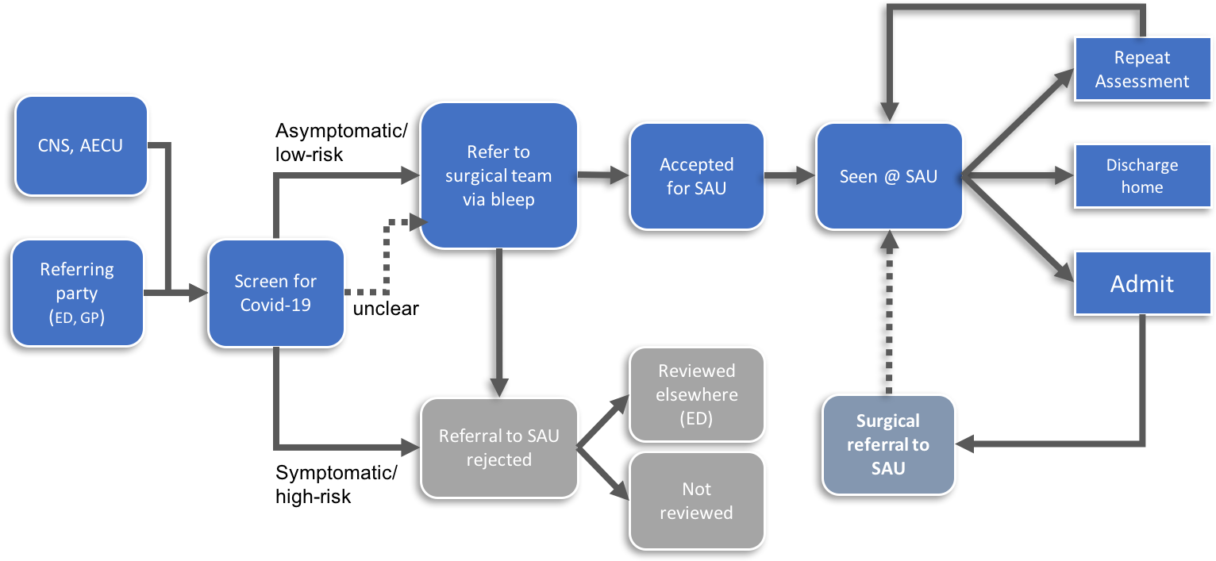

Patients are referred to SAU by clinical nurse specialists (CNS), GPs, the ambulatory medical team (AECU), and emergency department (ED, A&E) via bleep 24 hours a day. All patients should be screened for COVID-19 symptoms. If a patient is COVID-19 positive, symptomatic, has had significant exposure, or does not meet other referral criteria, SAU admission is rejected. If patients meet criteria for surgical review but not admission to SAU, the surgical team reviews elsewhere, usually in ED. If patients are considered low-risk for COVID-19 infection and meet other criteria they are accepted for SAU. Upon arrival, the patient checks in and is assessed by a surgical team member. Patients are discharged home, brought back later for further assessment or treatment, or admitted as inpatients. Some of these patients are seen in SAU after discharge for follow up.

Table 2: Parties referring to SAU

|  |  |  |
| --- | --- | --- |
|  | Mar-Apr | Jun-Jul |
| ED | 43 | 43 |
| Surgeons | 57 | 97 |
| GP/CNS | 8 | 13 |
| Other | 3 | 2 |

ED and the surgical team referred the most to SAU, with an increased number referred in the second period. Referrals were also made from the community by GP/CNS and other parts of the hospital.

1. Time to service delivery

Table 3: Delivery of investigations and surgical services in SAU

|  |  |  |
| --- | --- | --- |
|  | MAR-APR | JUN-JUL |
| 1. First doctor to review: |  |  |
| SHO | 18 | 87 |
| SpR | 40 | 42 |
| Consultant | 45 | 2 |
|  |  |  |
| 1. Time elapsed from referral to outcome | |  |
| Avg time elapsed | 2h 6 min | 2h 20 min |
| Greater than 4 hr avg | 5h 6 min | 6h 31 min |
| # encounters >4 hours | 8.1% (9) | 15% (27) |
|  |  |  |
| 1. Patients sent home and re-reviewed the following day | | |
| # pts brought back for USS-AP | 14 | 6 |
| average length of encounter | 1h 27min | 2h 4 min |
| Imaging order to report (same day) | 2h 36min | 3h 17min |
|  |  |  |

(a) During March-April, consultants were most often the first clinician to review, followed by registrars (SpR), then senior house officers (SHO). During June-July, the referral bleep was primarily held by a SHO, followed by senior review. (b) The average time from initial referral to initiating management was 2 hours and 6 to 20 minutes. For encounters longer than 4 hours, both duration and percentage of patients increased in June-July. (c) Some stable patients requiring ultrasound-abdomen pelvis (USS AP) were sent home overnight with scheduled investigations the following day. The average length of these encounters was over an hour shorter than when imaging was requested and done on the same day.

1. Screening of patients for COVID-19

Table 4: Screening for COVID-19 before SAU admission

|  |  |  |
| --- | --- | --- |
|  | MAR-APR | JUN-JUL |
| 1. Patients asked screening questions prior to review? | | |
| Yes | 43.5% | 58.1% |
| No/unknown | 56.5% | 41.9% |
|  | | |
| 1. Patients swabbed prior to review? | | |
| Yes | 14.1% | 46.9% |
| No | 85.6% | 53.1% |
|  | | |
| 1. Number of symptomatic patients sent to SAU: | | |
|  | 1 | 0 |

(a) During the March-April period, only 43.5% of patients had documentation regarding COVID-19 symptoms. This improved to 58.1% in June-July. (b) Increased swabbing was evident with an increase of 14.1% to 46.9% of patients referred to SAU having had a swab either on the day of the encounter or before SAU admission. (c) One symptomatic patient was sent to SAU during March-April, non in June-July.

**Discussion**

This study characterised general surgery acute and emergency services provision in a SAU established during the first wave of the COVID-19 pandemic in one of the most endemic areas of the UK. Data was collected during the initial wave (March-April 2020) and during a period with lower COVID-19 case numbers recorded (June-July 2020). This provided a unique opportunity to examine the efficacy of an SAU and how to mitigate COVID-19 infection risk.

Surgical assessment units can relieve pressure on emergency departments by redirecting referrals away from A&E’s (1, 3) and avoiding unnecessary admissions (4). We show that a significant proportion of SAU encounters are from parties outside of A&E (Table 2). This cohort of patients otherwise might have attended A&E but were instead managed in SAU. We note that during June-July there was a marked increase in the total number of patients seen (Table 1). This may be attributable to fear of COVID-19 exposure and a delayed hospital attendance in the first wave that has been noted elsewhere (5-7).

The COVID-19 pandemic necessitated the rapid implementation of infection risk-reduction protocols across the NHS. In keeping with this, SAU was maintained as a COVID risk-managed area by screening patients for clinical symptoms and checking for negative lab results. Screening of patients improved over time and likely was under-documented. Documentation improved over time as SAU nurses increasingly noted screening. Improved swabbing of patients (Table 4b) admitted to SAU was significant and, in light of asymptomatic cases presenting to hospital (2), screening in conjunction with lab testing could play a significant role in decreasing infection risk for patients. One patient was erroneously sent to SAU despite displaying COVID-19 symptoms (Table 3c). Proper documentation of COVID-19 status, understanding of referral criteria and effective communication between referring and receiving parties remains critical to avoid such errors.

Nosocomial transmission remains a concern (8), and decreasing time in hospital could enhance COVID-19 infection risk mitigation. An increase in the number, percentage, and duration of encounters lasting longer than four hours was seen in June-July (Table 3b). Looking at these instances individually, many were attributable to delays outside of SAU; possibly changes in other departments due to the pandemic could account for this. The increased number of patients seen in SAU along an initial review by a junior team member could account for extra time needed to work through a higher caseload and seek senior expertise (Table 3a, 3b). Front-end specialist review could reduce time for a patient in hospital (9), particularly in more complex cases. Patients sent home experienced reduced time in hospital compared to those that stayed in hospital awaiting further investigation (Table 3c). Using the SAU as a point of rapid access could reduce time and exposure to the hospital environment.

**Conclusion**

SAU can provide timely delivery of general surgery services during a pandemic with reduced risk of COVID-19 exposure. Effective screening for symptoms and increased lab testing can help to maintain the SAU as a “COVID-19 risk-managed” area.

**Recommendation**

Hospitals and other healthcare organisations should consider establishing SAUs to streamline care and provide acute and emergency surgical services. A robust system of risk assessment and documentation of a patient’s COVID-19 status is critical to the provision of surgical care during this pandemic.

**References**

1. Mohamed MS, Mufti GR. The surgical assessment unit--effective strategy for improvement of the emergency surgical pathway? J R Soc Med. 2005;98(1):14-7.

2. Abeysuriya S, Wasif S, Counihan C, Shah N, Iliodromiti S, Cutino-Moguel MT, et al. Universal screening for SARS-CoV-2 in pregnant women at term admitted to an East London maternity unit. Eur J Obstet Gynecol Reprod Biol. 2020;252:444-6.

3. Boyle E, McCormack H, O'Rourke A, Clarke-Moloney M, Kavanagh E, Grace P, et al. Improving patient care--the first year in a dedicated surgical assessment unit. Ir Med J. 2012;105(7):233-6.

4. Reeds MG, Andreani SM, Rohatgi A, Taylor FGM. Surgical Assessment Units: The Key to More Efficient Emergency Surgical Provision and Admissions? Qual Manag Health Care. 2020;29(1):7-14.

5. Ciacchini B, Tonioli F, Marciano C, Faticato MG, Borali E, Pini Prato A, et al. Reluctance to seek pediatric care during the COVID-19 pandemic and the risks of delayed diagnosis. Ital J Pediatr. 2020;46(1):87.

6. Zhao J, Li H, Kung D, Fisher M, Shen Y, Liu R. Impact of the COVID-19 Epidemic on Stroke Care and Potential Solutions. Stroke. 2020;51(7):1996-2001.

7. Cano-Valderrama O, Morales X, Ferrigni CJ, Martín-Antona E, Turrado V, García A, et al. Acute Care Surgery during the COVID-19 pandemic in Spain: Changes in volume, causes and complications. A multicentre retrospective cohort study. Int J Surg. 2020;80:157-61.

8. Abbas M, Robalo Nunes T, Martischang R, Zingg W, Iten A, Pittet D, et al. Nosocomial transmission and outbreaks of coronavirus disease 2019: the need to protect both patients and healthcare workers. Antimicrob Resist Infect Control. 2021;10(1):7.

9. Schultz H, Mogensen CB, Pedersen BD, Qvist N. Front-end specialists reduce time to a treatment plan for patients with acute abdomen. Dan Med J. 2013;60(9):A4703.

10. Seretis C, Archer L, Lalou L, Yahia S, Katz C, Parwaiz I, et al. Minimal impact of COVID-19 outbreak on the postoperative morbidity and mortality following emergency general surgery procedures: results from a 3-month observational period. Med Glas (Zenica). 2020;17(2):275-8.